Chaplain to the Beauchamp Community

The Beauchamp Community is a registered charity founded by Earl Beauchamp in 1864 as Almshouses for retired estate workers. Later, housing for retired clergy was included. It is now a retirement community, situated at the northern edge of Malvern Link.

The Beauchamp Community is an inclusive Anglo-Catholic Extra-parochial place. Until approximately 1990, St Leonard’s was the Parish Church of Newland. It is now leased to the Community as its Private Chapel. Sung services on Sundays and Feast Days are held in Church, daily Mass in the separate Chapel of All Souls. Sunday and Feast Day services are in traditional language, weekday services in modern language. The altars in both Church and Chapel are ad orientem. Incense is used several times a year at High Masses. The RWA is around 30, split approximately 40-60 between members of the Community and people from the wider community who appreciate the style of worship we offer.

The Beauchamp Community has 50 residents, with a total of four active priests. Three priests are active in leading worship, joined by other, non-resident clergy on an occasional basis.
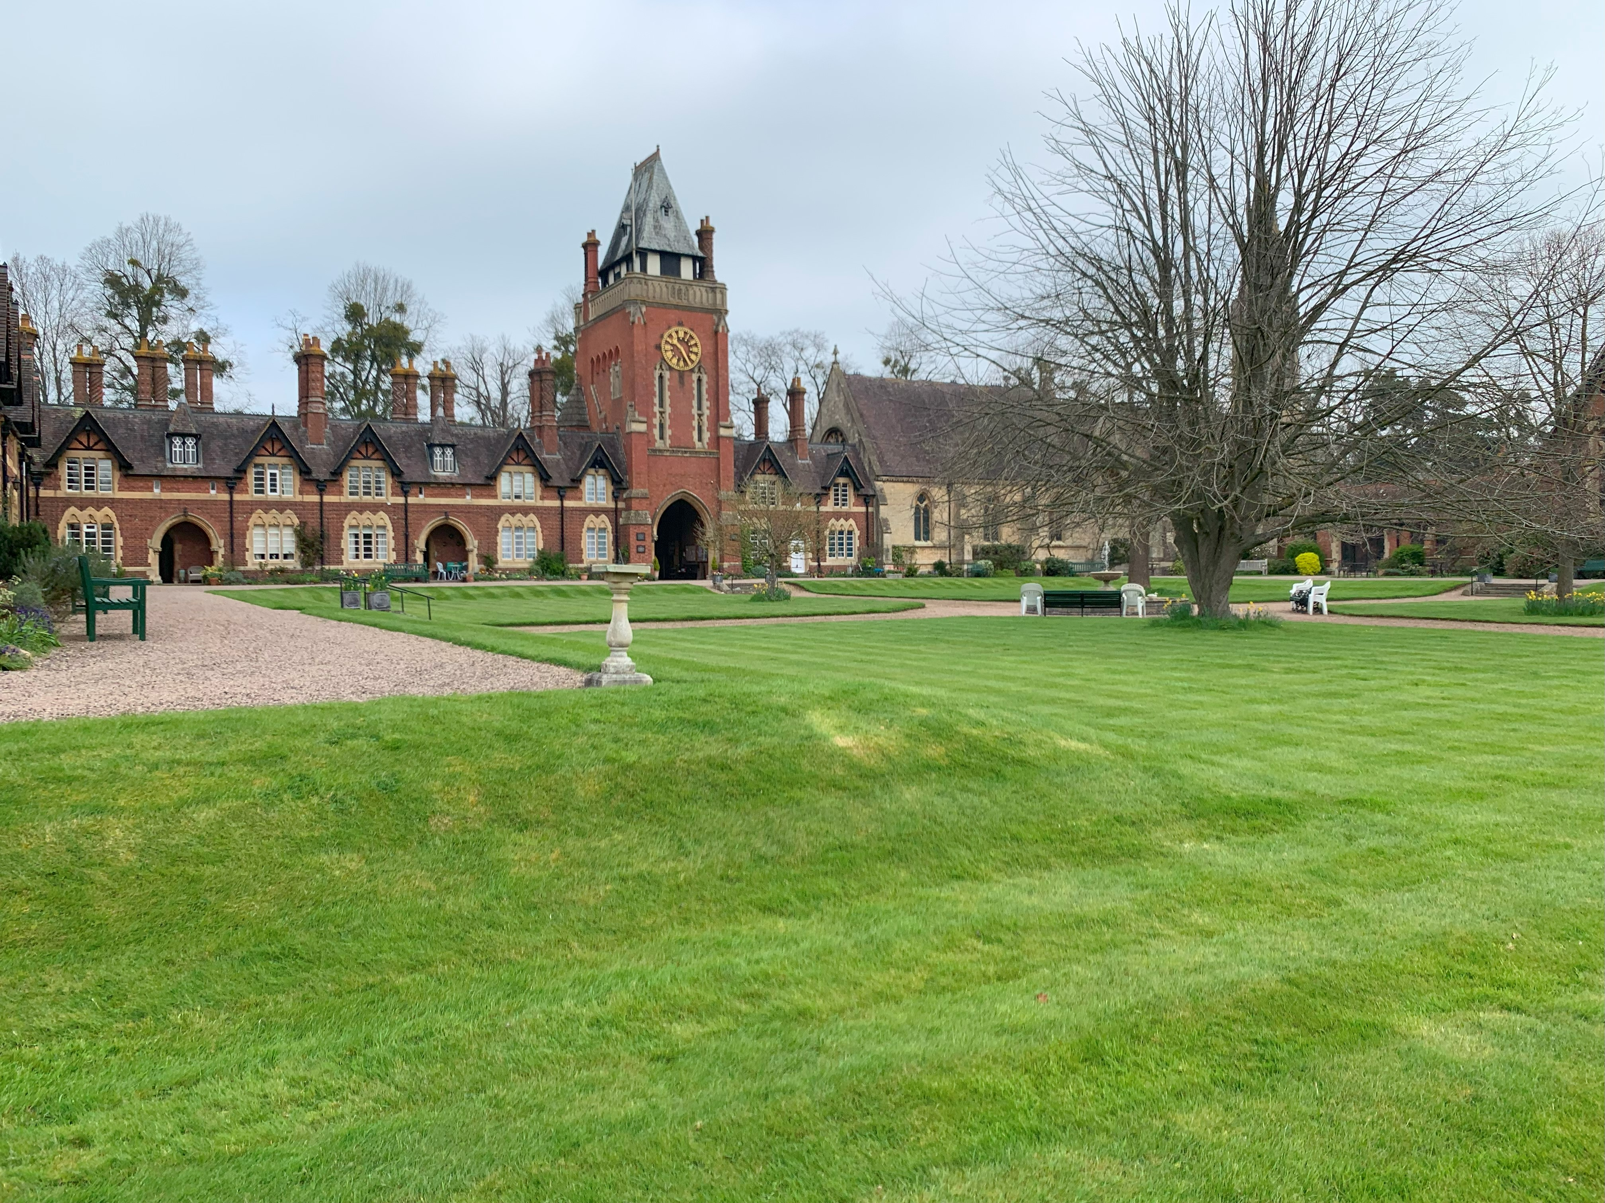
Our Church & Chapel.
St Leonard’s was finished in 1864 by the 6th Earl of Beauchamp Frederick Lygon. As a Grade I listed church it is lavishly decorated floor to ceiling with art works and stained glass by Clayton & Bell of London. The Reredos and Sedilia have been fully restored in recent years, as has our organ which stands beside three of the most amazing Italian marble pillars. Our font dates back the now demolished 12th century church St Thomas ‘a’ Beckett which stood nearby.
All Souls Chapel is situated off the Cloister which links St Leonards to the Boardroom and Wardens Lodge. All Souls Chapel was the chancel of St Thomas ‘a’ Becketts and was relocated in 1875 to act as the mortuary chapel to the Almshouses.

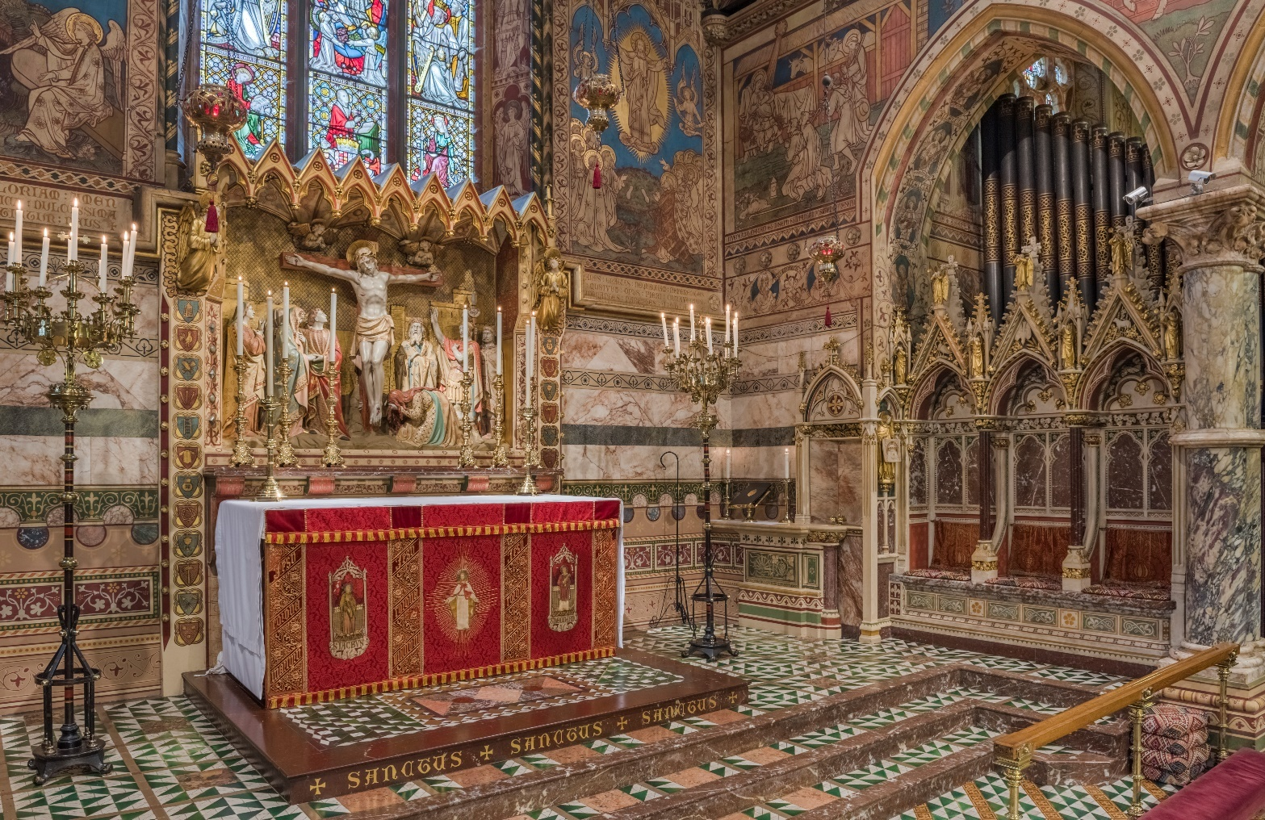
The Local Area
The Beauchamp Community is situated on the Worcester edge of Malvern about 10 minutes from the M5, giving fast and easy access to the rest of the Midlands. Malvern also benefit from a regular rail service to Worcester and beyond.
There are good local GP Surgeries and pharmacies either a short walk or drive away. Also with in a 10-minute walk are Morrisons, Aldi, M&S, Boots, Costas, Nero’s and a wide range of other retail outlets. Our local pub The Swan is a slow 5-minute walk and serves a range of local beers & ciders, as well as some great restaurant and bar food.

The Chaplain’s House (Grade II listed)
This fully renovated dwelling dates from the first phase of building here at The Beauchamp Community and was finished in 1864. The Chaplain’s House is situated between the Clock Tower and St Leonard’s Church. There are unrivalled views over the grounds, set against the backdrop on the Malvern Hills. The property benefits from a main door opening onto our stunning Quadrangle, and a kitchen door giving more private access to a dedicated parking space.
Ground Floor.
The ground floor consists of an office, spacious living room with a dual aspect. A modern recently refurbished kitchen and a downstairs cloakroom.
First Floor.
There are three upstairs bedrooms, two of which have superb views over the Quadrangle and grounds. There is a walk-in wardrobe and fitted bathroom.
One of the bedrooms has a veiled balcony tucked away behind a period door, which gives the best view of St Leonard’s and its wonderfully decorated interior.
Outside.
There are extensive grounds and an option to help out with the gardening club. There are also a number of allotments, a pond, as well as a beautifully stocked orchard. Access to the Malvern Countryside is by ways of a private gate and stream crossing, leading to miles and miles of stunning walking.
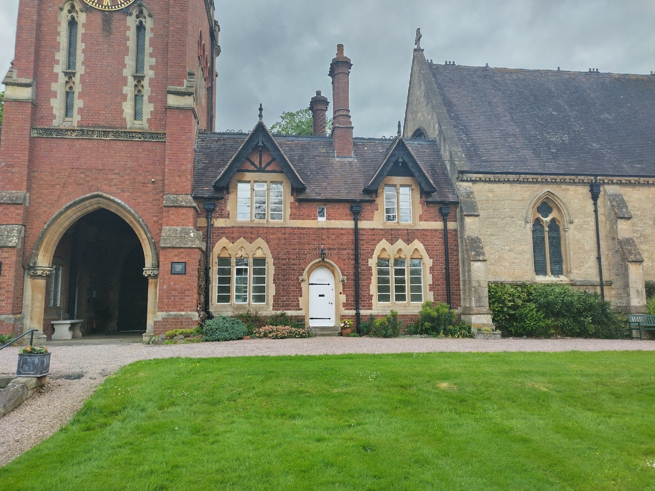

Duties as an Office Holder

1. To have charge of St Leonard’s Church and All Souls Chapel.
- Supervise and liaise with other Clergy, Organist, Master of Ceremonies, Sacristan.
- To organise the Clergy rota for Sunday and weekday masses and to publish weekly details of Services for residents and congregation, including updating the intercessions lists.
- Preside at occasional Baptisms, Weddings and Funerals or delegate to fellow Clergy.

2. To share with the Warden the Pastoral care of the residents of the Beauchamp Community
- Act as Deputy Safeguarding Lead.
- Regular weekly meeting with the Warden.
- Administer Home Communion as required.
- Write a fortnightly piece for the Community newsletter, The Whisperer.

3. To liaise with outside organisations and in particular maintain good relations with the Diocese.
- Hold the Bishop of Worcester’s Licence as Chaplain.
- Act as liaison with the Bishops, Archdeacon and Area Dean within the Diocese.

5. To liaise with the Board of Trustees.
- To attend Trustees’ meetings.
- Present a written report to the Trustees twice a year in advance of their meetings.
- Must maintain the confidence of the Trustees.

6. Current Remuneration for three days week including Sundays
- Voluntary Honorarium of £3,500.00 per annum.
- Residency within the Community free of charge.
- Council Tax, Electricity and Gas will be paid.
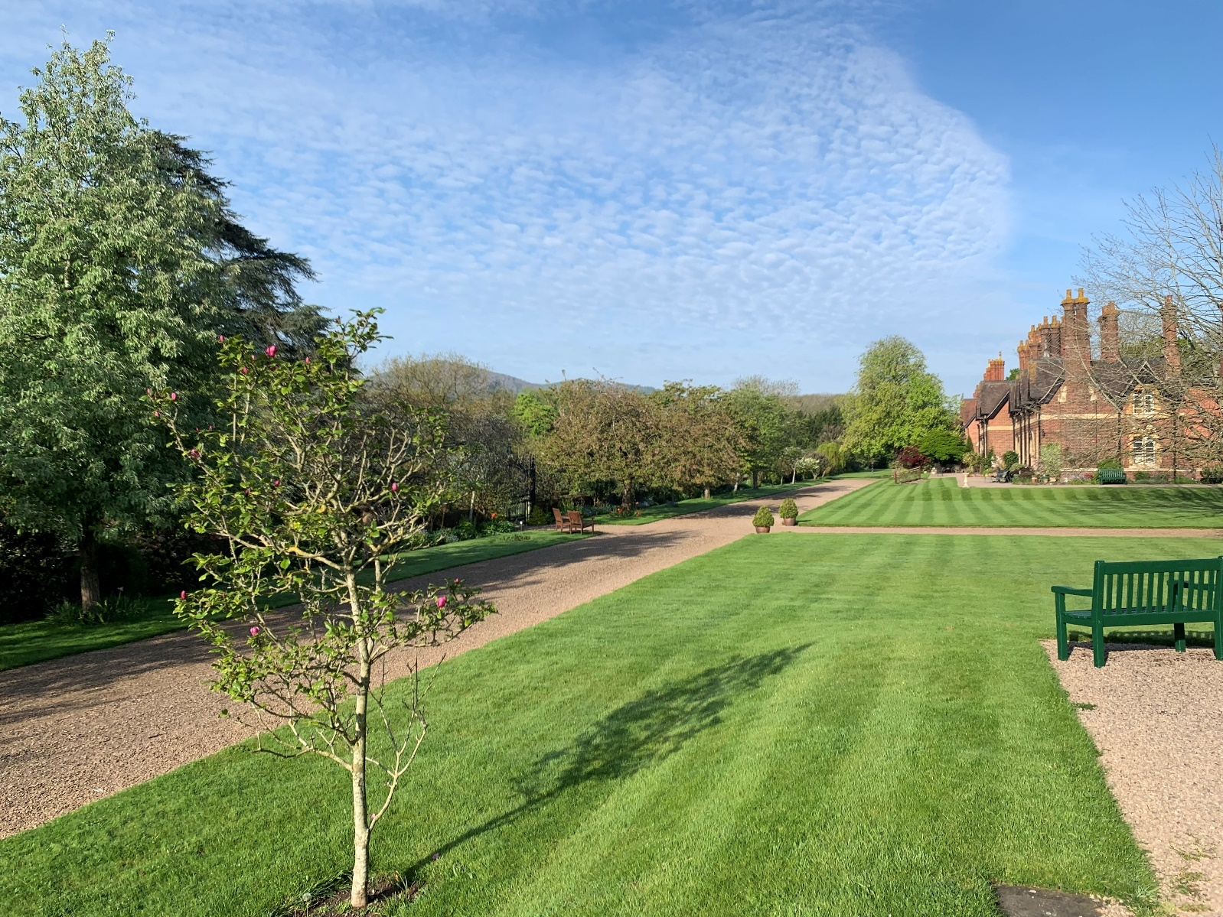

Personal Specification
We are looking for a subject matter expert with...
- A desire to understand, relate to, and engage with the varied aspects of life and people in our Almshouse Community.
- Good IT skills, with the ability to produce rotas and necessary paperwork.
- A proven Safeguarding record.
- A current enhanced DBS.
- Warmth, compassion, wisdom, tolerance and a sense of humour.
- Skills to communicate with both regular worshippers and those in the wider community.
- ‘Outside the box’ thinking who is prepared to innovate and encourage spiritual learning.
- The ability to apply Christian teaching in a personal and sensitive way to meet the needs of individuals alongside encouraging and developing faith and prayer life.
- To work with the laity in encouraging and developing their faith.
- An approach which values current Anglo-Catholic church traditions whilst accepting creativity in all forms of worship.

- The ability to prioritize and organise the workload bearing in mind the part-time nature of the post and have the drive and energy needed for ministry in an Almshouse Community.
- Relate well to others.
- Be a motivator, delegator, and listener.
- Be a person of prayer and teacher of scripture.
- Nurture the Christian spirit within the entire Almshouse Community.
- Display the compassion and understanding needed to knit together a diverse community.
- Be inclusive to all residents and those within the wider church.
- Help develop, encourage, and grow our new worshipping communities.
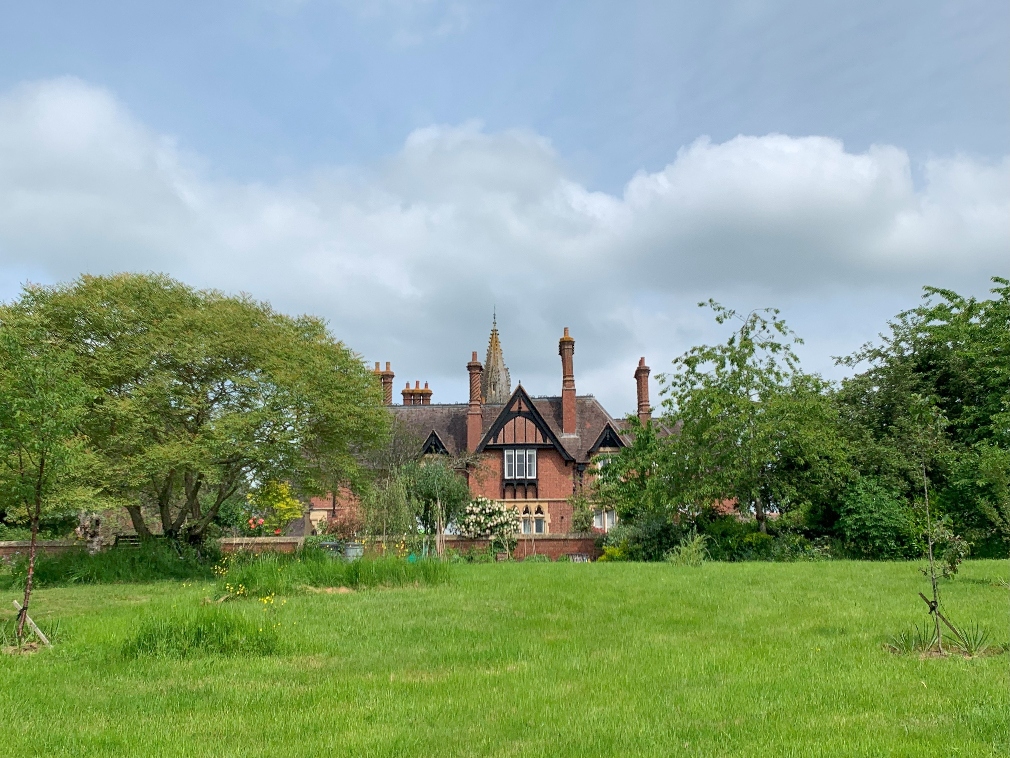
What you are not responsible for
- Health & Safety
- Finance
- Maintenance
- IT, Website & Social Media
- HR
- Contractors
- No PCC
- Recruiting
- Grounds

